CC-112L

Programming Fundamentals Laboratory 03
Introduction to C & Structured Program Development – II

Version: 1.0.0

Release Date: 17-02-2024

Department of Information Technology University of the Punjab
Lahore, Pakistan

Contents:
- Learning Objectives
- Required Resources
- General Instructions
- Activities
  - In-Lab Activity
    - Task 01: Factorial Calculator
    - Task 02: Quadratic Equation Solver
    - Task 03: Printing Stars
    - Task 04: Complex Number Calculator
    - Task 05: Reverse a number
Submissions
- Evaluations Metric
- References and Additional Material

Learning Objectives:
- Using printf Statement
- Understanding of Escape Sequence
- Use of Appropriate Format Specifier
- Taking input using Scanf
- Declaration of Variables of different Data Types

Resources Required:
- Desktop Computer or Laptop
- Microsoft ® Visual Studio 2022

General Instructions:
- In this Lab, you are NOT allowed to discuss your solution with your colleagues, even not allowed to ask how is s/he doing, this may result in negative marking. You can ONLY discuss with your Teaching Assistants (TAs) or Lab Instructor.
- Use of any AI TOOL will award F GRADE in the Lab course Definitely.
- Your TAs will be available in the Lab for your help. Alternatively, you can send your queries via email to one of the followings.

Teachers:
Course Instructor | Dr Natalia Chaudary | natalia.chaudhry@pucit.edu.pk
Teacher Assistants | M. Nabeel | bitf19m0@pucit.edu.pk
 | M. Anas Irfan | bitf21m047@pucit.edu.pk

Task 01: Factorial Calculator

Write a C program that calculates and displays the factorial of a given non-negative integer entered by the user. The factorial of a number n is the product of all positive integers up to n.

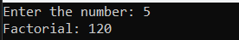

Task 02: Quadratic Equation Solver
Write a C program which takes the input of the coefficients of Quadratic Equation and unknown variable. Solve the quadratic equation and display the Result on the console. Let the coefficients can be any Real number and the unknown variable can be any integer.
[Hint: Quadratic equation: ax^2 + bx + c].
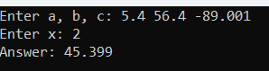

Task 03: Printing Stars
Write a C program which: [Hint: Use simple printf]
  - Take input from the User.
  - Output Stars Patterns as shown at the following output screen as shown IFF(If and only If) the input is 10, otherwise display the message that “The input password for rows was not correct to the print the Stars”.

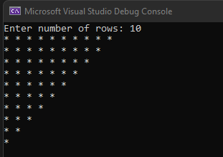

Task 04: Complex Number Calculator

Write a C program that takes two complex numbers as input from the user, performs operations such as addition, subtraction, multiplication, conjugate calculation and displays the results with proper formatting using printf(), escape sequences, format specifiers, and scanf().

Task 05 (BONUS): Reverse a number
Create a C program that:
  - Prompts the user to input an integer of Fixed 5 digits
  - Outputs the number with the digits reversed.
For example, if the input is 12345, the output should be 54321.

Submissions:
  - For In-Lab Activity:
    - Save the files on your PC.
    - TA’s will evaluate the tasks online

References and Additional Material:
  - if…else Statement in C
https://www.programiz.com/c-programming/c-if-else-statement

  - for-loop Statement in C
https://www.programiz.com/c-programming/c-for-loop

  - do-while Statement in C
https://www.programiz.com/c-programming/c-do-while-loops

  - switch-case Statement in C
https://www.programiz.com/c-programming/ c-switch-case-statement

  - break-continue Statement in C
https://www.programiz.com/c-programming/c-break-continue-statement

